**08 – Tuple/Set**

**Ex. No. : 8.1 Date:27/4/24**

**Register No.: 231501015 Name: Aniruth S V**

**Binary String**

Coders here is a simple task for you, Given string str. Your task is to check whether it is a binary string or not by using python set.

Examples:

Input: str = "01010101010"

Output: Yes

Input: str = "REC101"

Output: No

**For example:**

| **Input** | **Result** |
| --- | --- |
| 01010101010 | Yes |
| 010101 10101 | No |

**Program:**

str=input()

bset={'0','1'}

flag=0

if set(str).issubset(bset):

print("Yes")

else:

print("No")

**Output:**

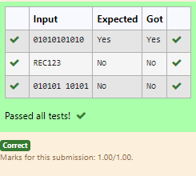

**Ex. No. : 8.2 Date:27/4/24**

**Register No.: 231501015 Name: Aniruth S V**

**Check Pair**

Given a tuple and a positive integer k, the task is to find the count of distinct pairs in the tuple whose sum is equal to **K**.

**Examples:**

**Input**: t = (5, 6, 5, 7, 7, 8 ), K = 13

**Output**: 2   
Explanation:   
Pairs with sum K( = 13) are  {(5, 8), (6, 7), (6, 7)}.   
Therefore, distinct pairs with sum K( = 13) are { (5, 8), (6, 7) }.   
Therefore, the required output is 2.

**For example:**

| Input | Result |
| --- | --- |
| 1,2,1,2,5  3 | 1 |
| 1,2  0 | 0 |

**Program:**

t = eval(input())

k = int(input())

seen = set()

pairs = set()

count = 0

for num in t:

complement = k - num

if complement in seen:

pair = (min(num, complement), max(num, complement))

if pair not in pairs:

pairs.add(pair)

count += 1

seen.add(num)

print(count)

**Output:**

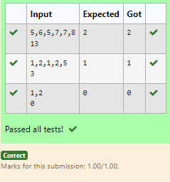**Ex. No. : 8.3 Date:27/4/24**

**Register No.: 231501015 Name: Aniruth S V**

**DNA Sequence**

The **DNA sequence** is composed of a series of nucleotides abbreviated as 'A', 'C', 'G', and 'T'.

For example, "ACGAATTCCG" is a **DNA sequence**.

When studying **DNA**, it is useful to identify repeated sequences within the DNA.

Given a string s that represents a **DNA sequence**, return all the **10-letter-long** sequences (substrings) that occur more than once in a DNA molecule. You may return the answer in **any order**.

**Example 1:**

**Input:** s = "AAAAACCCCCAAAAACCCCCCAAAAAGGGTTT"

**Output:** ["AAAAACCCCC","CCCCCAAAAA"]

**Example 2:**

**Input:** s = "AAAAAAAAAAAAA"

**Output:** ["AAAAAAAAAA"]

**For example:**

| **Input** | **Result** |
| --- | --- |
| AAAAACCCCCAAAAACCCCCCAAAAAGGGTTT | AAAAACCCCC  CCCCCAAAAA |

**Program:**

s = input()

sequences = {}

result = []

for i in range(len(s) - 9):

substring = s[i:i+10]

sequences[substring] = sequences.get(substring, 0) + 1

for substring, frequency in sequences.items():

if frequency > 1:

result.append(substring)

for i in result:

print(i)

**Output:**

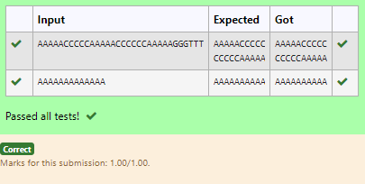

**Ex. No. : 8.4 Date:27/4/24**

**Register No.: 231501015 Name: Aniruth S V**

**Print repeated no**

Given an array of integers nums containing n + 1 integers where each integer is in the range [1, n] inclusive.There is only **one repeated number** in nums, return this repeated number. Solve the problem using [set](http://118.185.187.137/moodle/mod/resource/view.php?id=734).

**Example 1:**

**Input:** nums = [1,3,4,2,2]

**Output:** 2

**Example 2:**

**Input:** nums = [3,1,3,4,2]

**Output:** 3

**For example:**

| **Input** | **Result** |
| --- | --- |
| 1 3 4 4 2 | 4 |

**Program:**

nums = input()

l=nums.split()

seen = set()

for num in l:

if num in seen:

r=num

seen.add(num)

print(r)

**Output:**

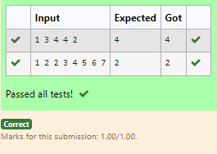

**Ex. No. : 8.5 Date:27/4/24**

**Register No.: 231501015 Name: Aniruth S V**

**Remove repeated**

Write a program to eliminate the common elements in the given 2 arrays and print only the non-repeating elements and the total number of such non-repeating elements.

Input Format:

The first line contains space-separated values, denoting the size of the two arrays in integer format respectively.

The next two lines contain the space-separated integer arrays to be compared.

Sample Input:

5 4

1 2 8 6 5

2 6 8 10

Sample Output:

1 5 10

3

Sample Input:

5 5

1 2 3 4 5

1 2 3 4 5

Sample Output:

NO SUCH ELEMENTS

**For example:**

| **Input** | **Result** |
| --- | --- |
| 5 4  1 2 8 6 5  2 6 8 10 | 1 5 10  3 |

**Program:**

sizes = list(map(int, input().split()))

arr1 = list(map(int, input().split()))

arr2 = list(map(int, input().split()))

set1 = set(arr1)

set2 = set(arr2)

unique1 = set1 - set2

unique2 = set2 - set1

unique_elements = list(unique1) + list(unique2)

if unique_elements:

print(" ".join(map(str, unique_elements)))

print(len(unique_elements))

else:

print("NO SUCH ELEMENTS")

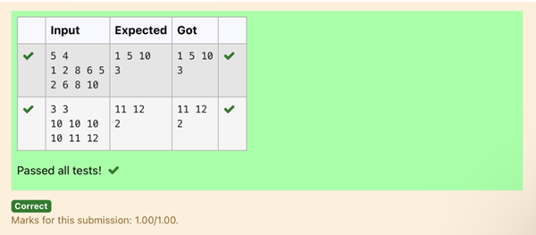**Output:**

**Ex. No. : 8.6 Date:27/4/24**

**Register No.: 231501015 Name: Aniruth S V**

**Malfunctioning Keyboard**

There is a malfunctioning keyboard where some letter keys do not work. All other keys on the keyboard work properly.

Given a string text of words separated by a single space (no leading or trailing spaces) and a string brokenLetters of all distinct letter keys that are broken, return the number of words in text you can fully type using this keyboard.

Example 1:

Input: text = "hello world", brokenLetters = "ad"

Output:

1

Explanation: We cannot type "world" because the 'd' key is broken.

**For example:**

| **Input** | **Result** |
| --- | --- |
| hello world  ad | 1 |

**Program:**

text = input().upper()

brokenLetters = input().upper()

broken_set = set(brokenLetters)

count = 0

for word in text.split():

if all(letter not in broken_set for letter in word):

count += 1

print(count)

**Output:**

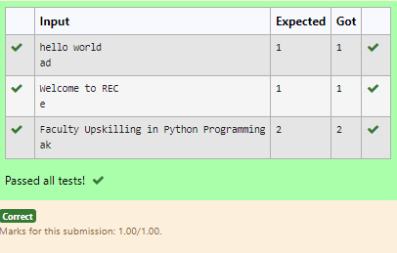

**Ex. No. : 8.7 Date:27/4/24**

**Register No.: 231501015 Name: Aniruth S V**

**American keyboard**

Given an array of strings words, return *the words that can be typed using letters of the alphabet on only one row of American keyboard like the image below*.

In the **American keyboard**:

* the first row consists of the characters "qwertyuiop",
* the second row consists of the characters "asdfghjkl", and
* the third row consists of the characters "zxcvbnm".

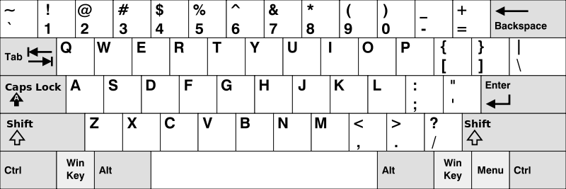

**Example 1:**

**Input:** words = ["Hello","Alaska","Dad","Peace"]

**Output:** ["Alaska","Dad"]

**Example 2:**

**Input:** words = ["omk"]

**Output:** []

**Example 3:**

**Input:** words = ["adsdf","sfd"]

**Output:** ["adsdf","sfd"]

**For example:**

| **Input** | **Result** |
| --- | --- |
| 4  Hello  Alaska  Dad  Peace | Alaska  Dad |

**Program:**

n=int(input())

l=[]

for j in range(n):

l.append(str(input()))

row1 = set("qwertyuiop")

row2 = set("asdfghjkl")

row3 = set("zxcvbnm")

result = []

for word in l:

lower_word = set(word.lower())

if lower_word <= row1 or lower_word <= row2 or lower_word <= row3:

result.append(word)

if(len(result)!=0):

for i in range(len(result)):

print(result[i])

else:

print("No words")

**Output:**

